**Setting up Application Environment**

**Install IBM Cloud CLI**

|  |  |
| --- | --- |
| DATE | 3 NOVEMBER 2022 |
| TEAM ID | PNT2022TMID02998 |
| PROJECT NAME | SMART FASHION RECOMMENDER APPLICATION |
| TASK ASSIGNED TO | IRFAN ALI S |

**Step 1:**

Login to your IBM Cloud [***https://cloud.ibm.com/login*** an](https://cloud.ibm.com/login)d in-search bar you can type **Container registry** and click to get started.

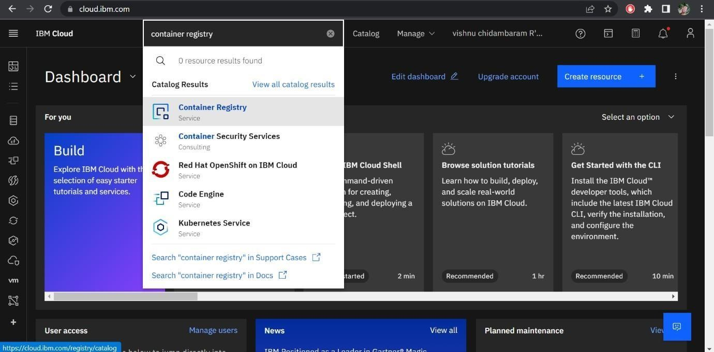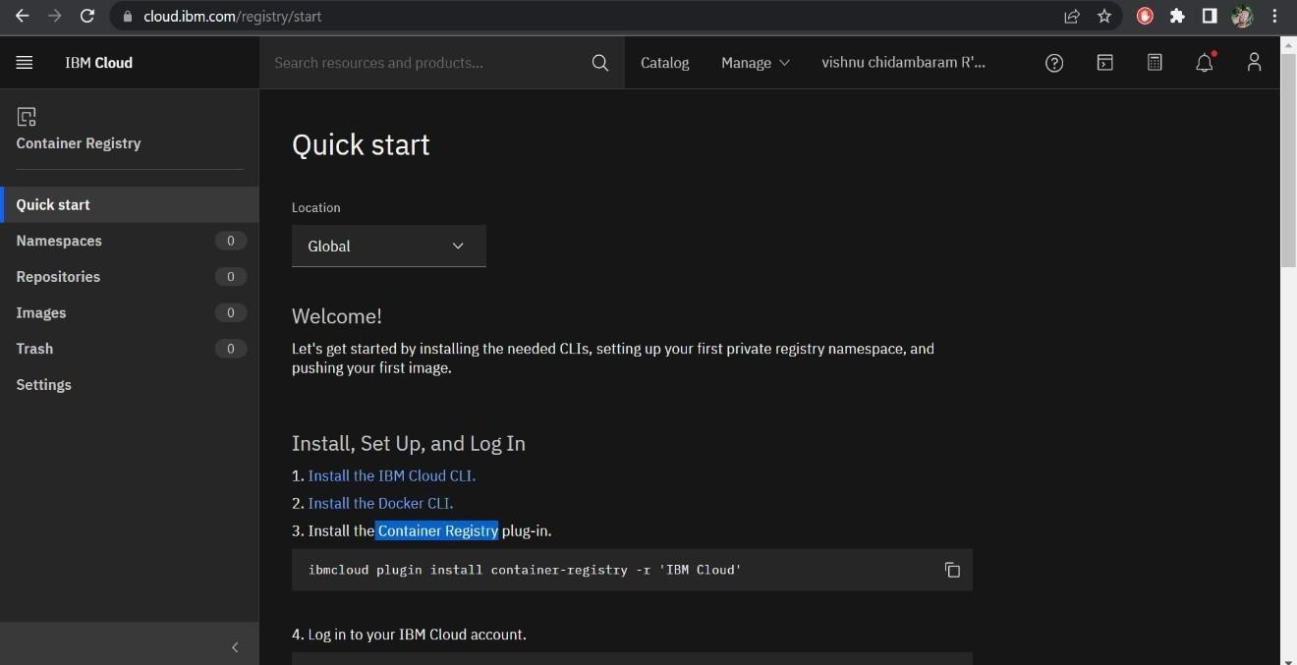

**Step 2:**

Follow and do the step given in this page one by one [***https://cloud.ibm.com/registry/***](https://cloud.ibm.com/registry/%20start)

[***start***](https://cloud.ibm.com/registry/%20start)

**Step 3:**

Run the command in power shell,

***(New-Object Net.WebClient).DownloadString('https://clis.cloud.ibm.com***

***/install/powershell')***

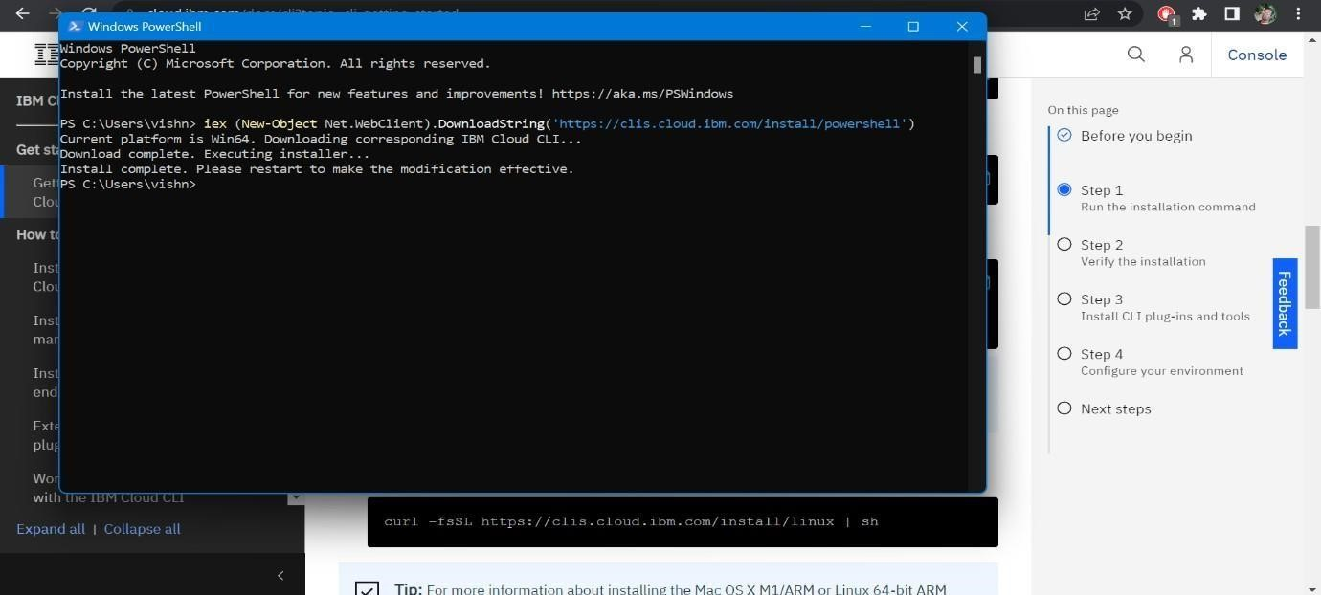

**Step 4:**

Enter the command in cmd:

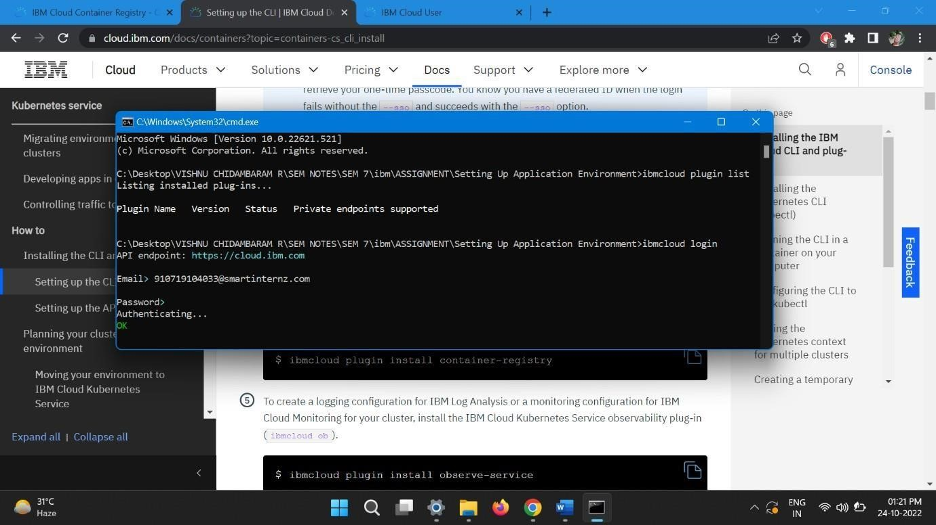

**Step 5:**

Run all the command one by one in cmd

[***https://cloud.ibm.com/docs/containers?topic=containers-cs_cli_install***](https://cloud.ibm.com/docs/containers?topic=containers-cs_cli_install)

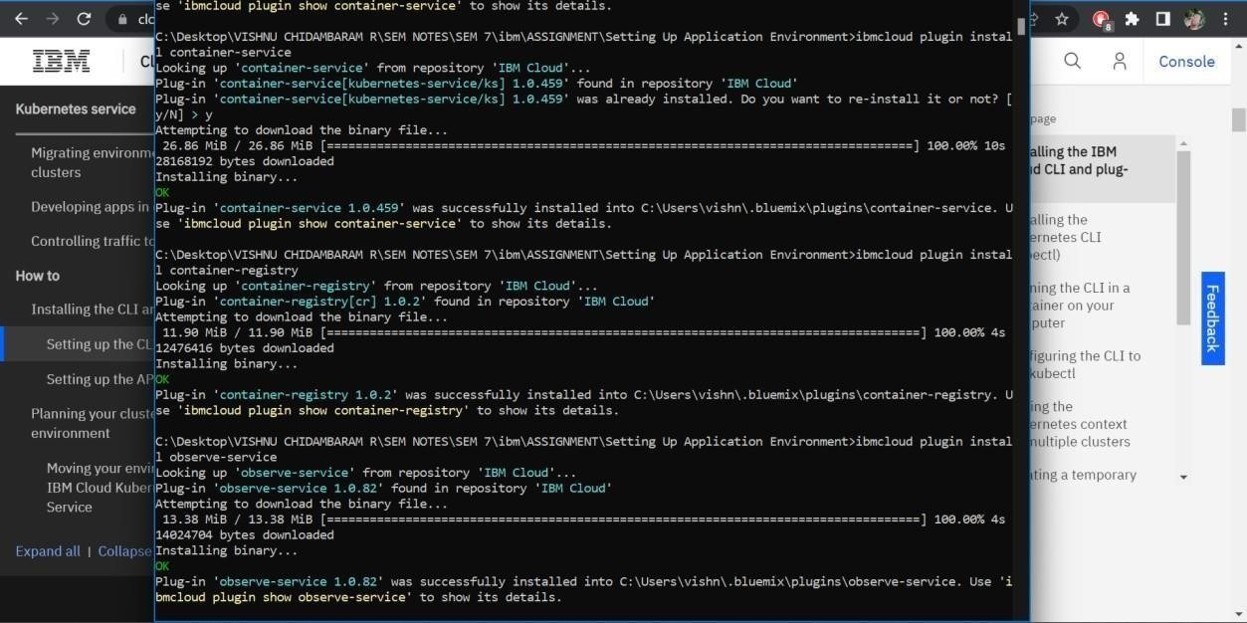

**Step 6:**

Finally, you will get the IBM CLOUD CLI in your desktop